SPRING TERM 2 NEWSLETTER!!

FEBRUARY 2023

Dear Parent/Carer,

It’s good to have all the children back after the half term! And we use this opportunity to welcome all new families and children.
Spring is a time of the year we look forward to as the evenings starts to lighten up. The last 5 weeks before the half term was busy at preschool with various activities including celebrating the Chinese New Year. We had a Dental nurse visit the preschool on our “People who help us” theme week. We also had Levi the CAT visit the preschool on our “Pet” theme week. The children had so much fun on the NSPCC Number fund raising day doing various number activities, playing number games and exploring with numbers. And thanks for your generous donation, we raised a total of £66.00 for NSPCC. Some images of the various activities and what the first 5 weeks of this term looks like are included in this newsletter.
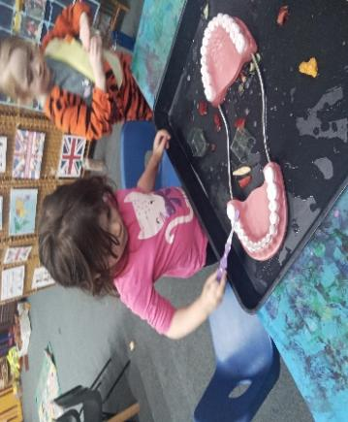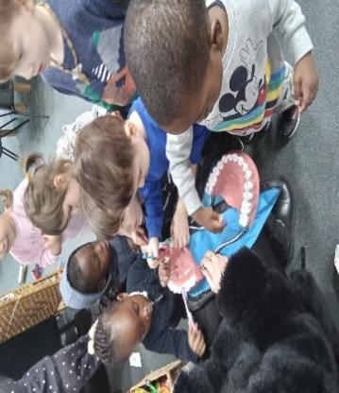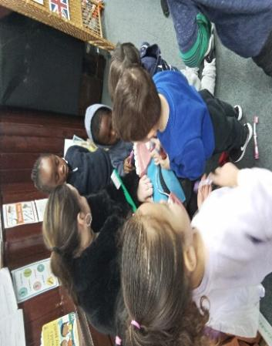
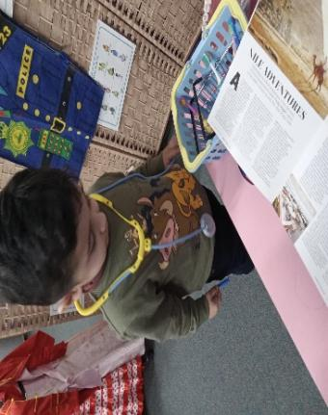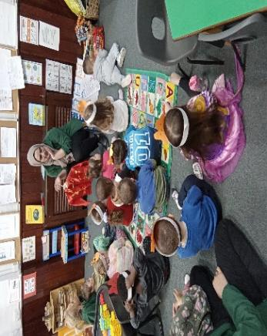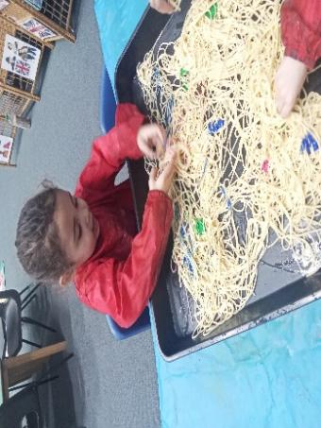
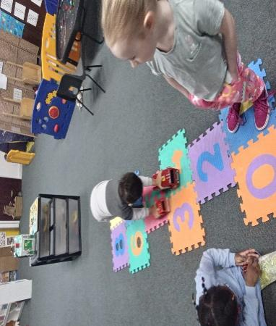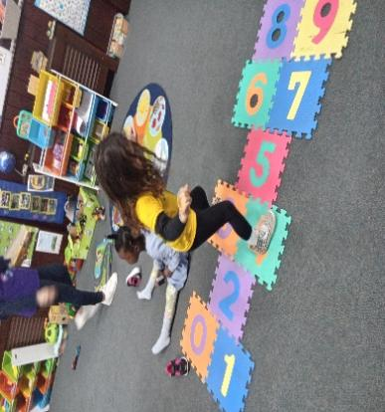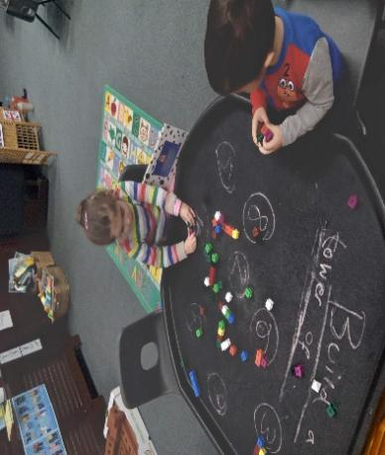
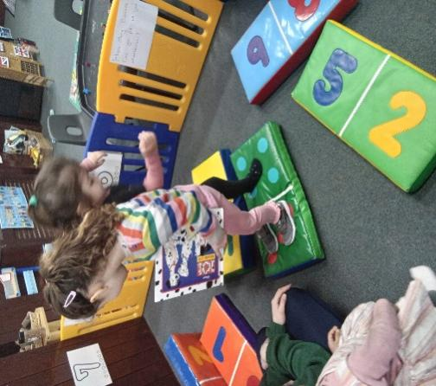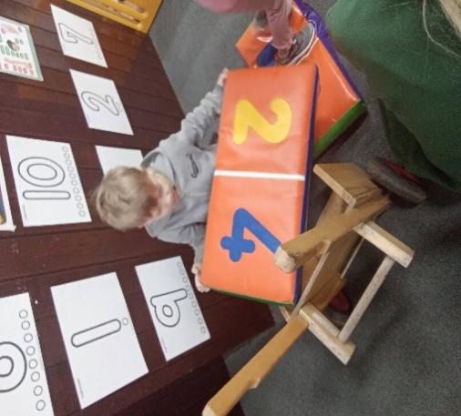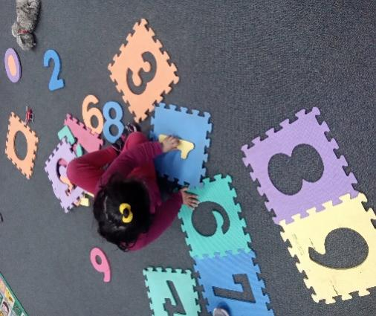
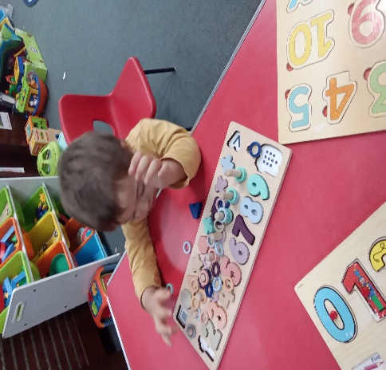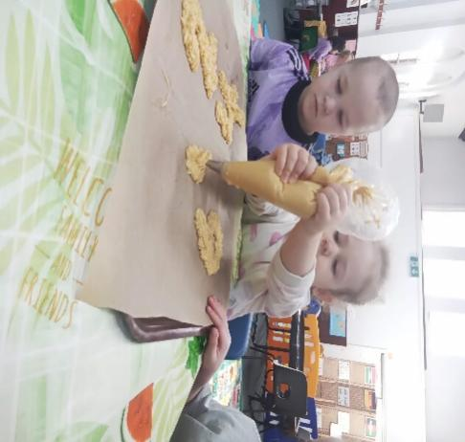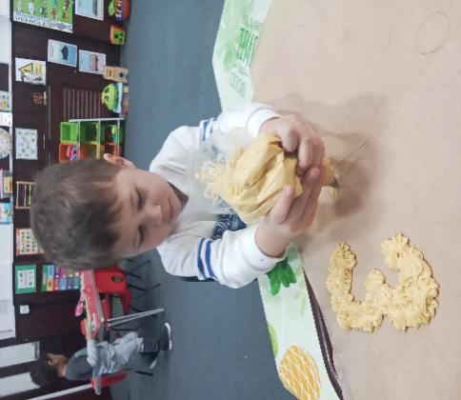
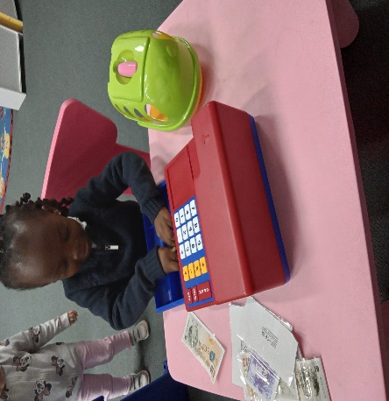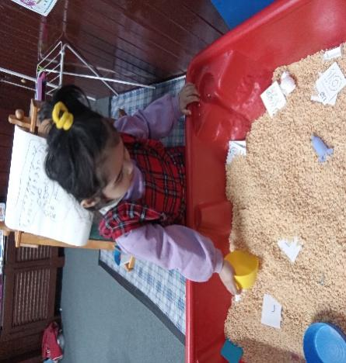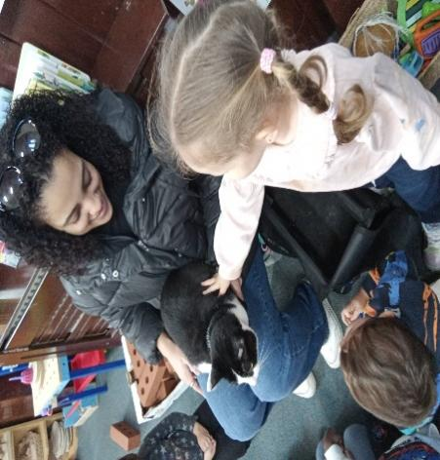
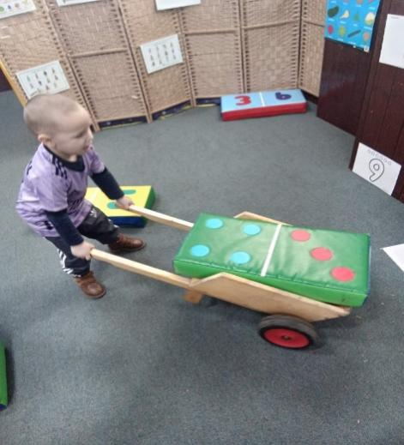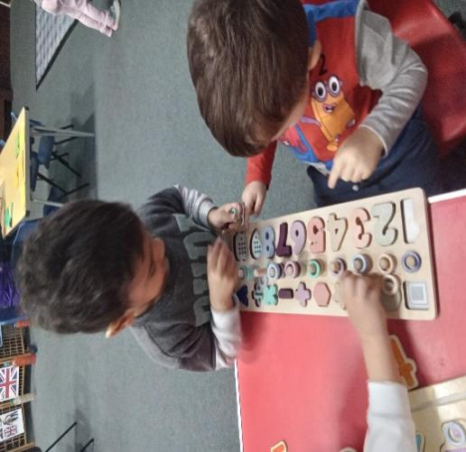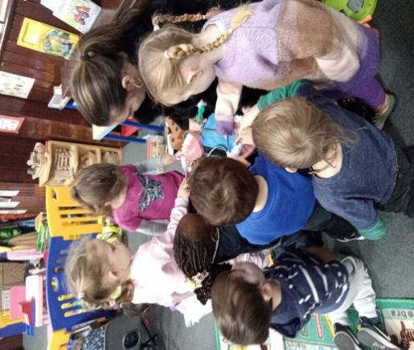

There are few updates and reminders in this newsletter, so do read it carefully and make a note of all the dates.
World Book Day
The world book day for this year will be on the the 2nd of March. Your child may bring their favourite book and dress up in their favourite book character to preschool on the day.
Mother’s Day
In celebration of all mothers, carers and grandmothers this year, we will like to invite mums and grand moms for tea/coffee and biscuit morning at preschool on Friday 17th March at 11.15am. Could you please let Ms Rachael know if you will be coming so we can prepare adequately for everyone.
Parents Consultation Week
You will have the opportunity to meet with your child’s Key person on the week of the 20th March to discuss your child’s progress and more. Further information will be communicated close to the time.
International Day
The international day missed in December due to many absences have now been scheduled for last day of term, Thursday 30th March 2023. For those new to preschool, International day is a celebration of cultures and diversity at preschool.
You may bring food, flags, music, dance, arts etc from your cultural background to share with other parents and children on the day. We ask that you dress your child up in their traditional costumes or any other around the world they fancy. The preschool will be open as normal on the day but parents can join us from 11.30am to 12.30pm.
Absence
If your child is going to be absent for any reason, please send a message as early as possible, ideally before 9.00am. It is part of our safeguarding policy that all absences are logged. We will always ask a reason for absence, this is important for us to monitor and inform others of any transmittable illnesses, such as sickness bugs, chicken pox and Covid. Please call for each day of absence, unless you know the date of return, e.g. self isolating / sickness for 48 hours.
Please note, if you have given your child Calpol, or any other pain relief, we will kindly ask you to keep your child at home. If they have had to be given medicine, they are not well enough for preschool, so kindly keep them at home. Calpol and other pain relief medicines can mask other symptoms, so please do not give them medication and send them into preschool.
Change of address/telephone numbers
Please keep us updated if you move house or if your contact number changes. We need to be able to get hold of you in an emergency, so please do let us know if your details change, this includes email addresses, residential addresses and telephone numbers.
Late Pick Up
There have been many occasions recently where parents and carers have been significantly late to collect their child without reason. Kindly note that late arrival at the end of sessions does have an impact on the smooth running of the day and the late pick up charge will be enforced going forward.
30 hours childcare
If your child has turned 3 years between January and March 2023, they may be eligible for 30 hours starting from April 2023. You may check your eligibility using this link https://www.gov.uk/apply-30-hours-free-tax-free-childcare or by calling HMRC childcare helpline on 0300 123 4097

The themes for this half term are as follows:
Week | Themes
Week 1 | Life Cycle of Plants
Week 2 | Book Week
Week 3 | Alphabets
Week 4 | Healthy Eating
Week 5 | My Community
Week 6 | Easter
Last day of term is Thursday 30th March at 12.30pm
Summer term starts – Tuesday 18th April, 2023

